Portal DWI
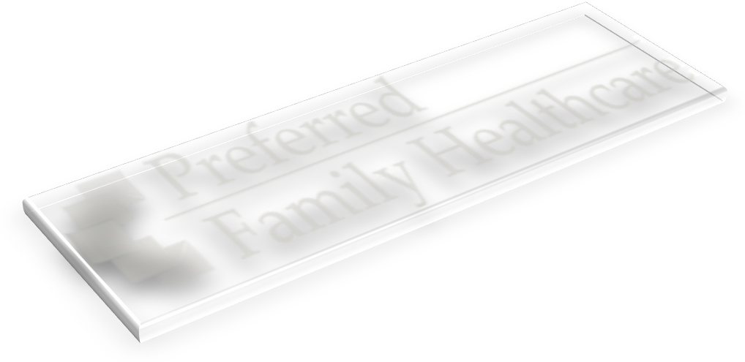
Welcome to Virtual World Counseling! We are excited that you have made the decision and commitment to participate in this innovative and effective support program!
This program will not satisfy any SATOP requirements you have.
Our Mission
“Preferred Family Healthcare Continuously Strives to be a Dynamic, Caring Organization United to Assist Others in Achieving Their Potential.”

Our Philosophy
In six simple words our philosophy is that “We Meet You Where You Are”. We have individuals come to us from a wide variety of places in reference to physical location and in regards to alcohol use.
We recognize that not everyone can participate in program services offered in our traditional programs due to time and travel constraints. Our Virtual World provides easy and immediate access to individual counseling, group education, and group counseling from your home, your office, or where ever you may be at the time that our services in the Virtual World are scheduled to be delivered.
All you need is a computer system that meets the following requirements for accessing the Jibe 3D virtual world:
- Windows 2000 or later; Mac OS X 10.4 or later.
- Compatible web browser (Google Chrome or Firefox…both free to download).
- Any standard 3d graphics card made in this millennium should work.
- Average-speed internet connectivity (e.g., wifi, cable, ethernet).
- Web Cam – if not on the computer; this can be purchased at Best Buy for around $40.00
  - Headset Optional (around $15-$20.00)
We know that everyone who experiences negative consequences connected with alcohol use is not a full blown alcoholic. Acknowledging this we have developed this program that is focused on exploring alcohol use to assist you in determining the harmful effects that alcohol use has had in your life as well as to determine next best steps that will benefit you individually.
Confidentiality
We will respect your confidentiality and we ask that you would do the same for others. In order for open disclosure to take place, participants must feel safe. What is said in a group session needs to remain in a group session. We encourage you to be honest.

You have the added benefit of an Avatar in regards to confidentiality. Please do not share your real name or identifying information with other participants or ask others for this information. This will make it easier for you and others to share thoughts and feelings openly.

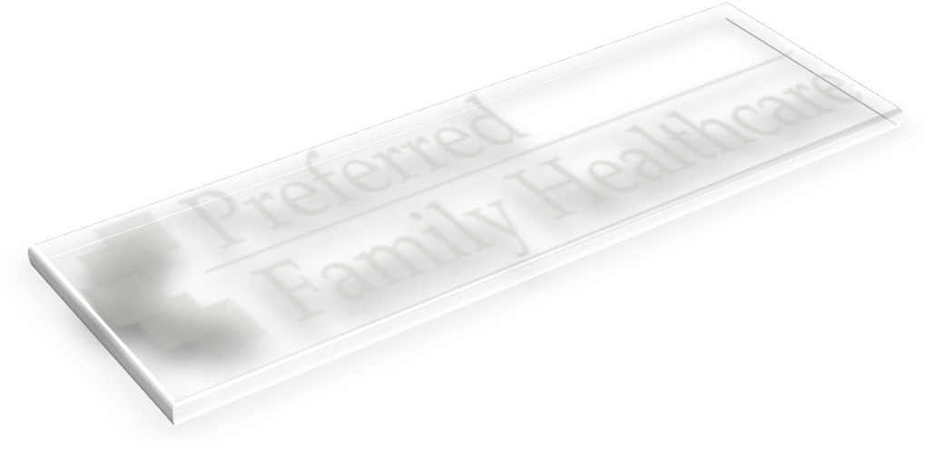
We will protect your confidentiality as an alcohol and drug abuse treatment provider as governed by federal laws and regulations. Generally, the program may not say to a person outside the program that a consumer attends the program or disclose any information identifying a participant in this program UNLESS:

- The legal guardian consents in writing (if applicable)
- The disclosure is allowed by a court order;
- The disclosure is made to medical personnel in a medical emergency; or
- The disclosure is made to qualified personnel for research, audit, or program evaluation.

Violation of Federal law and regulations by a program is a crime. Suspected violations may be reported to appropriate authorities in accordance with Federal regulations.

Federal laws and regulations do not protect any information about suspected child abuse or neglect from being reported under State law to appropriate State or local authorities.

Pertinent information about your case will be shared between treatment staff to help facilitate the treatment process. If you share in a group or with another staff member, the content of your disclosure may be important and helpful to your treatment staff. Sharing this information is not a violation of your confidentiality. Information shared is about progress, discharge, and any other information important to your case.

Participant Feedback/Input
Preferred Family Healthcare strives to consistently improve the quality of our programs. Your feedback is important to us. As a participant, you have the most direct experience with the services being provided therefore you have beneficial insight into the quality of the program. Many changes to programs have been made over the years as direct result of suggestions made by our participants, their families, and other agencies. We encourage you to provide input into programming activities by submitting suggestions via email to a staff member and by being honest on the Participant Satisfaction Survey completed at the close of treatment. In addition you will be required to complete three assessments (web based) upon admission, at discharge, and 3-6 months post discharge.

What You Can Expect
As you go through this program you can expect that you will be working with qualified professionals who understand the full continuum of alcohol use from that one poor choice that led to an uncomfortable situation to more progressed use that may be impacting one’s job performance, family relationships, legal situations, and/or general functioning. Where you fall on this continuum is for you to decide and we will walk with you to assist you in this process.
What you get out of this program is highly dependent on what you put into this process. You will be expected to complete homework assignments that may include journaling that will be discussed during group and individual sessions. We encourage you to be honest in your assignments as no one but you will see this information. We will also provide you with access to additional information via links so that you can further learn, evaluate your use on your own, and/or connect with others who may serve as supports.
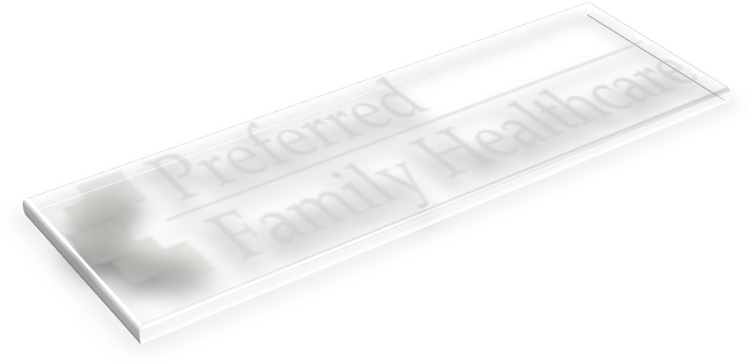
We do ask for you to remain open-minded and patient with regard to other members in the groups. Participants will be entering this program talking about various issues as they explore their use of alcohol; please be reminded that we value an exploration and supportive stance no matter what issues are brought to group. We have found this approach to be highly effective. Listening to others and sharing your thoughts are the keys to benefiting fully from this program.
Successful Completion
Participation in this program is a big commitment and not one to take lightly, as full attendance and participation is key to obtaining a successful completion.
Prior to successfully completing this program, all assignments will be completed and discussed, as well as establishment of a “Going Forward” plan that is reviewed in the final individual session.
Program Structure
There are 12 sessions offered over a 10-12 week period. The initial session will take approximately 1.5 hours while subsequent sessions will be 1.0 hour in length. Prior to the initial session you will have received and signed all necessary admission paperwork, and read and understood this handbook.
The initial session is an Introductory Individual Session that will serve as an Orientation to the program. Upon completion of this session the participant will have established:
- Registration & Creation of an Avatar
- Getting around and communicating with others in the VW
- Group Schedule & Attendance/Participation Expectations
- Understanding of Successful Discharge Criteria
- How to get the most out of each session
  - Opportunity vs. Nuisance
- Knowledge & Understanding of Confidentiality
- Beginnings of “Why you are Here”?

Sessions 2-11 will be group sessions that cover the following (however may not be in this order):
Lesson 1 Laws and Consequences - examines the driving privileges and the responsibility associated with that privilege. Examines laws associated with operating a motor vehicle while under the influence and impact their individual offense has had on them.
Lesson 2 Financial loss – examines the financial impact their offense has had on them personally as well as other losses caused by their offense. Discusses what impact another offense would have on them and identification of reasons to not re-offend.
Lesson 3 High Risk Situations for re-offense – Assists consumers to identify situations that have a higher risk of translating into re-offense. Assist the consumer to identify their personal high risk situations and develop a safety plan to avoid re-offense in those situations.
Lesson 4 Think your way out of Re-offending – Discusses techniques to utilize to assist consumers with thinking their way out of re-offending if in a high risk situation and challenges irrational beliefs associated with offending behavior.
Lesson 5 Seemingly Irrelevant Decisions – Examines how apparently unrelated decisions can affect risk of re-offense. Assists consumers to make connections, think ahead and how to make decisions to place yourself in low risk situations.
Lesson 6 Personality Characteristics and Moral Inventory – Explores personality and what makes up our personality. Assists consumers to identify problematic personality characteristics and how to utilize moral inventory to make changes in those areas.
Lesson 7 Rethinking Drinking – Examines norms associated with abstinence, low risk drinking and high risk drinking. Examines personal drinking patterns and symptoms of an alcohol use disorder.
Lesson 8 It’s up to you – Explores pros and cons of changing current drinking patterns. Educates on strategies for cutting down on drinking, and benefits of support. Develops the beginning of a change plan.
Lesson 9 Thoughts-> Attitudes -> Behaviors – Examines the relationship between thoughts attitudes and behavior. Provides education and practice on thought stopping techniques
Lesson 10 Stages of Change – Education on the the stages of change and practice identifying current stage of change on an issue and practice identification of steps to motivate oneself to the next stage in the change process.
The curriculum is set up as such that you will be able to join a group at any place during the process. Homework Assignments may be given at the end of each session to be completed for discussion by the next session.

The final session is a Closure & Next Steps Individual Session. During this session the following will be accomplished:
- Review of the Participants Established “Going Forward” Plan
- Completion of a Participant Satisfaction Survey
- Participant receipt of additional resources/links in their community and/or online

How do I get started?

Attached at the back of this handbook will be two copies of the Admission and Consent form. Once you have decided to participate in the program, you are expected to complete one copy and return to the court for them to fax or scan to PFH for enrollment.

Below are payment options. Remember the entire payment must be received before programming will begin. The charge for the program is $375, to be paid prior to beginning the program. Payment will not be refunded if you withdraw or fail to complete the program. Payment should occur by going to PFH.org, then online payment, for the description drop down indicate this is Portal DWI. The client number you will enter will be 999657. Or you may mail a money order to Preferred Family Healthcare, c/o Portal DWI, 900 E. LaHarpe Street, Kirksville, MO 63501. After payment is made you will need to email PortalDWI@pfh.org stating your interest in starting the program. You are expected to enroll in this program within 4 weeks of your plea. The court will be notified weekly who has paid and begun treatment or not.

Per regulatory requirements, a copy of the independent audit report of Preferred Family Healthcare, Inc. is available for review upon request.
Skype Tutorial
As a way to help monitor your participation in each group of the program, PFH uses audio/video conference software so we can see your face and verify your identity. This program is free to install. Prior to your first group session, you will need to setup a Skype account.
To install Skype, to go www.skype.com/go/downloading/ and SkypeSetup.exe will automatically download. Click SkypeSetup.exe and install the program, following the prompts. You will be walked through setting up your free Skype account as part of the installation. If you have any problems or confusion with installing or using Skype, visit http://www.skype.com/intl/en-us/support/user-guides/ for support.
You will be prompted, during the Skype installation/setup process, to set your profile picture. Skype will use your webcam to take a picture of your face. PFH requires a clear picture of your face for identity. You can add/change a profile picture at any time by opening Skype, then clicking “Skype”, scroll to “Profile”, and then click “Change your picture”. A new window will appear and click “Take Video Snapshot” at the top right corner. Then follow to directions to save the snapshot.
You are required to keep Skype open during any group or individual session with PFH so that your identity can be verified instantly. Have your speakers turned up enough to hear Skype ring when the facilitator calls your Skype account…you will be prompted to answer the call (the software is user friendly and will let you know when someone is calling). The facilitator may Skype you at any time during groups.
If you have any additional questions that could not be answered by online Skype Support (link above), you may contact PFH staff, whose contact info will be provided to you during your first individual session.
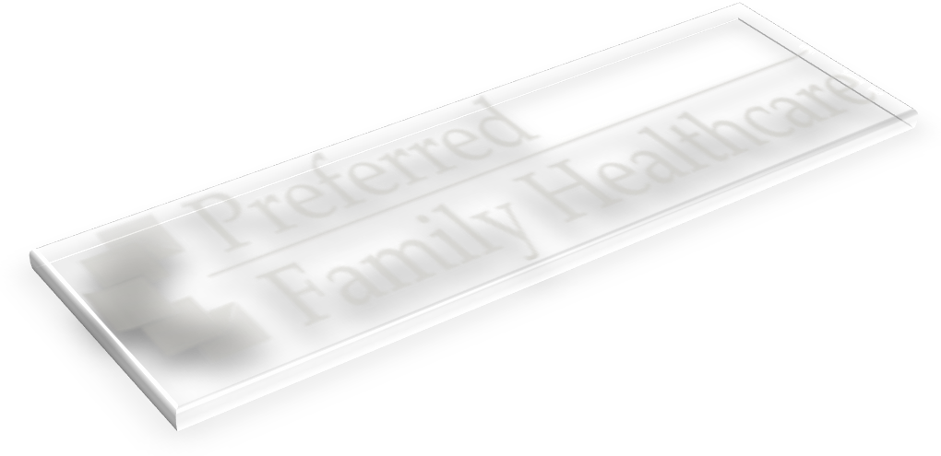
Additional Resources

PFH Home Page: http://www.pfh.org/
PFH Contact for Email Feedback: portaldwi@pfh.org
National Treatment Locator: http://www.samhsa.gov/treatment/index.aspx
Do I have a Drinking Problem? http://www.alcoholscreening.org/Home.aspx


ADMISSION AND CONSENT – Portal DWI
PLEASE PRINT LEGIBLY
Client Name: _______________________________________________ Phone: _____________________________
Address: ______________________________ City: _____________________ State: ___________ Zip: _________
Email: _________________________________@__________________________ Date of Birth: _____/_____/_____
Emergency Contact: _______________________________________________ Phone: _________________________
Signing this form gives permission to PFH to contact the Emergency Contact in the Event of an Emergency disclosing information specific to the Emergency Event.
Referral Source: __________________________________________________ Phone: _________________________
Attorney: _______________________________________________________ Phone: _________________________
Signing this form gives permission to PFH to disclose information in writing and/or verbally specific to attendance, participation, and completion of treatment.
Circuit Court: ___________________________________________________ Phone: _________________________
Signing this form gives permission to PFH to disclose information in writing and/or verbally specific to attendance, participation, and completion of treatment.
I, __________________________________________, am voluntarily participating in the Portal DWI program and have a clear understanding of program expectations through reading the Program Manual, which includes information on the Notice of Privacy Practices. I understand that attendance and participation are keys to obtaining a successful completion. I understand this program will NOT satisfy any SATOP requirements. I agree to participate in baseline and follow-up surveys during, and upon completion of, the educational program. I also give consent to release my personal identification & contact information to Missouri Institute of Mental Health (MIMH). I also give MIMH permission to contact me (via email) regarding surveys, and allow them to report related data to Preferred Family Healthcare.
I understand that it is my responsibility to access necessary technological equipment listed below in order to participate in services offered in this program, and by signing below I am acknowledging that I have this equipment available to me.
- Windows 2000 or later; Mac OS X 10.4 or later.
- Compatible web browser (Google Chrome or Firefox…both free to download).
- Any standard 3d graphics card made in this millennium should work.
- Average-speed internet connectivity (e.g., wifi, cable, ethernet).
- Web Cam – if not on the computer; this can be purchased for around $40-$60

I understand my records are protected under the federal regulations governing Confidentiality of Alcohol and Drug Abuse Client Records, 42 CFR Part 2, and HIPAA, and cannot be disclosed without my written consent unless otherwise provided for in the regulations. I also understand that the above consent is subject to revocation by me at any time, except to the extent an action has been taken in reliance on this consent. This consent will stay in effect until account is settled.
By signing below, I acknowledge that I am aware and in agreement with assuming full financial responsibility for the services I receive in the amount of a one-time $375 payment, to be paid prior to beginning the program. I understand that this will not be refunded to me should I withdraw or fail to complete the program. Payment should occur by going to PFH.org, then clicking on “Online Payment”. The client number you will enter will be 999657. Or you may mail a money order to Preferred Family Healthcare, c/o Portal DWI, 900 E. LaHarpe Street, Kirksville, MO 63501. After payment is made you will need to email PortalDWI@pfh.org stating your interest in starting the program.
You must enroll in this program within exactly 4 weeks of your plea (which is most likely the date of this document). You must then complete your initial Introductory Individual Session within 3 weeks of enrollment. Finally, you must complete the entire program within 26 weeks and complete the Survey(s) requested, including the Survey required after all sessions are complete

Client Signature: _____________________________________________________ Date: _______________________

Completed form should be faxed to DWI Portal Program, PFH, at 660-665-3989 or scanned to PortalDWI@pfh.org by the court.
OFFICE USE ONLY
Date Payment Received: |  | Date Program Start: |  |  |  |  | Date Program Completion: |  |  |  | Completion Status:
Sessions Attended: | 1 | 2 | 3 | 4 | 5 | 6 | 7 | 8 | 9 | 10 | 11 | 12

Staff Signature: ____________________________________________________ Date: _______________________
ADMISSION AND CONSENT – Portal DWI
PLEASE PRINT LEGIBLY
Client Name: _______________________________________________ Phone: _____________________________
Address: ______________________________ City: _____________________ State: ___________ Zip: _________
Email: _________________________________@__________________________ Date of Birth: _____/_____/_____
Emergency Contact: _______________________________________________ Phone: _________________________
Signing this form gives permission to PFH to contact the Emergency Contact in the Event of an Emergency disclosing information specific to the Emergency Event.
Referral Source: __________________________________________________ Phone: _________________________
Attorney: _______________________________________________________ Phone: _________________________
Signing this form gives permission to PFH to disclose information in writing and/or verbally specific to attendance, participation, and completion of treatment.
Circuit Court: ___________________________________________________ Phone: _________________________
Signing this form gives permission to PFH to disclose information in writing and/or verbally specific to attendance, participation, and completion of treatment.
I, __________________________________________, am voluntarily participating in the Portal DWI program and have a clear understanding of program expectations through reading the Program Manual, which includes information on the Notice of Privacy Practices. I understand that attendance and participation are keys to obtaining a successful completion. I understand this program will NOT satisfy any SATOP requirements. I agree to participate in baseline and follow-up surveys during, and upon completion of, the educational program. I also give consent to release my personal identification & contact information to Missouri Institute of Mental Health (MIMH). I also give MIMH permission to contact me (via email) regarding surveys, and allow them to report related data to Preferred Family Healthcare.
I understand that it is my responsibility to access necessary technological equipment listed below in order to participate in services offered in this program, and by signing below I am acknowledging that I have this equipment available to me.
- Windows 2000 or later; Mac OS X 10.4 or later.
- Compatible web browser (Google Chrome or Firefox…both free to download).
- Any standard 3d graphics card made in this millennium should work.
- Average-speed internet connectivity (e.g., wifi, cable, ethernet).
- Web Cam – if not on the computer; this can be purchased for around $40-$60

I understand my records are protected under the federal regulations governing Confidentiality of Alcohol and Drug Abuse Client Records, 42 CFR Part 2, and HIPAA, and cannot be disclosed without my written consent unless otherwise provided for in the regulations. I also understand that the above consent is subject to revocation by me at any time, except to the extent an action has been taken in reliance on this consent. This consent will stay in effect until account is settled.
By signing below, I acknowledge that I am aware and in agreement with assuming full financial responsibility for the services I receive in the amount of a one-time $375 payment, to be paid prior to beginning the program. I understand that this will not be refunded to me should I withdraw or fail to complete the program. Payment should occur by going to PFH.org, then clicking on “Online Payment”. The client number you will enter will be 999657. Or you may mail a money order to Preferred Family Healthcare, c/o Portal DWI, 900 E. LaHarpe Street, Kirksville, MO 63501. After payment is made you will need to email PortalDWI@pfh.org stating your interest in starting the program.
You must enroll in this program within exactly 4 weeks of your plea (which is most likely the date of this document). You must then complete your initial Introductory Individual Session within 3 weeks of enrollment. Finally, you must complete the entire program within 26 weeks and complete the Survey(s) requested, including the Survey required after all sessions are complete

Client Signature: _____________________________________________________ Date: _______________________

Completed form should be faxed to DWI Portal Program, PFH, at 660-665-3989 or scanned to PortalDWI@pfh.org by the court.
OFFICE USE ONLY
Date Payment Received: |  | Date Program Start: |  |  |  |  | Date Program Completion: |  |  |  | Completion Status:
Sessions Attended: | 1 | 2 | 3 | 4 | 5 | 6 | 7 | 8 | 9 | 10 | 11 | 12

Staff Signature: ____________________________________________________ Date: _______________________

